Ms. 4192
EFFECTS OF PHOSPHORUS AND SULFUR NUTRITION ON SOLUBLE SUGARS AND GROWTH IN CLITORIA TERNATEA L.

by M. G. ZAROUG and D. N. MUNNS

Land, Air and Water Resources University of California, Davis, CA 95616 U.S.A.

KEY WORDS

Nodulation Regrowth Root reserves Symptoms

SUMMARY

Effects of P and S on growth and regrowth were assessed in a greenhouse trial in which Clitoria was grown through three cuttings on a deficient soil with a factorial combination of 4 levels of P and 3 levels of S.
Phosphorus deficiency caused stunting, flowering delay, and a rusty appearance of leaflets. Sulfur deficiency caused stunting and chlorosis. With successive cuttings, P deficiency became less severe and S deficiency more severe.
Nodulation, observed at the end of the trial, was influenced more by S than by P. Maximal nodulation was achieved with the highest S level, at any of the highest three P levels.
Root and stubble dry weight, and food reserves evaluated by etiolated regrowth and by soluble sugar in roots and stubble, responded positively to both P and S, and correlated with each other and with shoot growth preceding the final cutting. For maximal etiolated regrowth, the S requirement was higher than the P requirement.
INTRODUCTION
Phosphorus and S interact on growth of a variety of legumes when they are grown in soils deficient in both nutrients ^{2,3,10,19}. Different authors have reported increase in S requirement in forage legumes with successive cuttings^{11,22} ; perhaps not only due to depletion of S, since species differ¹¹. Phosphorus requirement sometimes decreases with time after establishment^{7,16}. Therefore the present investigation was done to evaluate P and S interaction with time on Clitoria ternatea L.
Clitoria ternatea is grown and managed as a perennial forage plant. In perennial forages, the unharvested portions of the plants are particularly important as food reserves used during dormancy and subsequent regrowth ¹². Hence another aim of this investigation was to assess effects of P and S on food reserve

243
Plant and Soil 55, 243-250 (1980). 0032-079X/80/0552-0243$01.20
© Martinus Nyhof Publishers, The Hague. Printed in The Netherlands.
244 M. G. ZAROUG AND D. N. MUNNS
accumulation. These effects were measured as soluble sugar concentration in stubble and roots and by determining mass of shoot material regenerated in the dark (‘etiolated regrowth’).
MATERIALS AND METHODS
Seed of Clitoria ternatea was supplied by the Department of Range Management, Ministry of Agriculture, Khartoum, Sudan. Up to 60% of the seed normally is hard. For this reason, it was treated for 15 minutes with concentrated H₂SO₄ and rinsed with distilled water, with a resulting increase in percent germination from 38% to 98%.
The soil, surface (0-20 cm) material from a Josephine silt loam (Typic Hapludult), came from the Univ. of California Field Station at Hopland. It is slightly acid (pH 6.0 in saturation paste), and known to be both S and P deficient (Milton B. Jones, personal communication). Soil was air-dried, screened, mixed and weighed in 3 kg portions into plastic undrained pots with polyethylene liners. Micronutrients were applied to every pot at rates corresponding to 8 kg/ha each of CuC1₂, ZnC1₂, MnCl₂ and H₃BO₃. Sodium molybdate was added at 0.5 kg/ha.
Three levels of S (0, 20, and 40ppm referred to as S₁, S2, and S₃ respectively) were combined factorially with 4 levels of P (0, 50, 100 and 200 ppm, referred to as P₁. P₂, P₃ and P₄). Each treatment was replicated 6 times. Sulfur was added as K₂SO₄ solution, and P as CaHP0₄ powder. A solution of KCl was added to equalize K in all treatments.
Five seeds, inoculated with a Rhizobium isolate from Clitoria ternatea L. were planted per pot and thinned to 3 plants. Pots were watered to field capacity (29% by weight) daily with distilled water. Four weeks after planting 50 ppm N as NH₄NO₃ solution was applied to all pots because the foliage was yellow-green. The N corrected the symptom. Greenhouse air temperature (June-July) was kept in the range 21 to 32°C. No supplemental light was provided.
Tops were harvested 3 times, at 7,12, and 17 weeks after planting. Ten percent flowering in the P₄S₃ treatment was used as criterion for harvesting throughout the experiment. In the first harvest plants were cut directly above the second node, taking the cotyledons' attachment as the first node. In the second and third harvests only the new growth was clipped. Tops were dried at 70°C for 24 hours and weighed. After the third harvest, stubble and roots from 3 randomly chosen pots of each treatment were used for soluble sugar determination, and the other 3 pots were used for measurement of etiolated regrowth.
For etiolated regrowth, pots were watered the evening before the third harvest. The following morning, tops were harvested. Cotyledons and unifoliate leaves remaining below the second node were detached. Each pot then received 10 ppm S as K₂SO₄ solution. Pots were left in the dark for one week, when etiolated regrowth was removed, dried and weighed.
For soluble sugar determination, roots and stem bases were washed in tap water and blotted. Nodules were detached and their size and number recorded. The remaining roots and stubble were dried at 70°C for 24 hours, ground to pass a 40-mesh screen, and stored in tight plastic containers. Total and reducing sugars were determined by a Shaffer-Somogyi copper reduction procedure^{s} and nonreducing sugar was obtained by difference.
RESULTS
Growth, flowering and nodulation
Phosphorus-deficient plants were stunted and had small leaves, which reached the pinnate stage (5 leaflets) a week later than in other treatments. Similar
Nodule number and size were reduced by deficiency of S or P (Table 1). Addition of S increased nodule number and size more than addition of P and the greatest nodulation was in treatments with highest yield at the final harvest. This contrasts with observations that in Stylosanthes humilis S had little effect on early nodulation but P had a large effect⁹.
EFFECTS OF P AND S ON C. TERNATEA 245

observations have been made with Macroptilium atropurpureum²³ and Stylosanthes humilis⁸. Some plants in the P₁ treatments had leaves with rusty appearance, more pronounced when no S was applied. Senescence of cotyledons and unifoliate leaves began early in P-deficient plants, but when P was supplied, cotyledons remained present up to the final harvest and some were still green. Growth of the P₁ plants progressively improved with succeeding cuttings.
Symptoms of S deficiency did not appear until the second growth period, when plants without added S developed chlorotic leaflets. This agrees with observations on Trifolium repens ²². During the third period, leaflets of S deficient plants became brittle.
Flowers appeared, during the first growth period, at 5 weeks in the P₄ treatment, 3 days later in the P₃ and P₂ treatments, and not at all in the P₁ treatment. A similar flowering pattern occurred in the second growth period, except that flower buds now appeared in the P₁S₂ and P₁S3 treatments. At the third harvest, all treatments had some flowers except the P₃S₁ treatment.
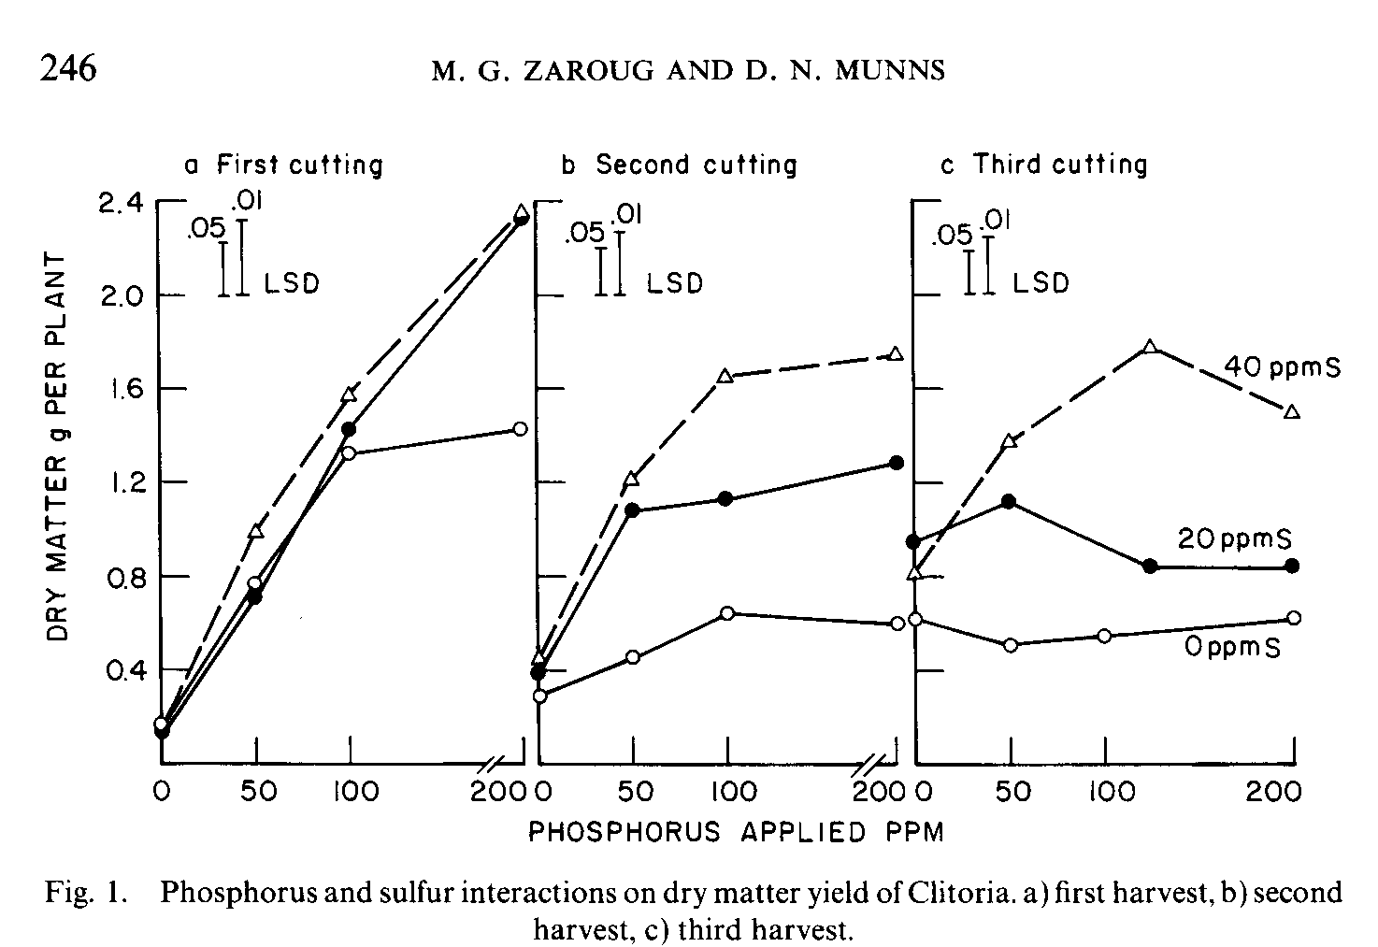
Shoot dry matter yield

During the first period of growth, addition of P linearly increased yield in the presence of S (Fig. la). Sulfur had no effect except in the P₄ treatment. Similar response has been obtained with Stylosanthes humilis ^{19, 21}. In the second period, both P and S increased the yield (Fig. lb). The first increment of P produced greater increase in yield than the second or third. In the third growth period, the effect of S increased, but the effect of P diminished: there was virtually no difference between various P levels at S_{I} and S₂; and at S₃ the highest level of P reduced the yield (Fig. lc). The increasing effect of S with time agrees with results for Macroptilium atropurpureum^{ll} and Trifolium repenS²².
Roots and stubble; sugars and regrowth

Increasing either P or S gave larger roots + stubble (Table 2), both variables having greater effect the higher the level of the other. Maximal root + stubble weight was attained in the P₄S₃ treatment, whereas maximal shoot weight was attained in the P₃S₃ treatment.
Etiolated regrowth was increased by only the first increment of S or P (Table 2). Etiolated regrowth correlated highly significantly with both roots + stubble dry weight (r = 0.874) and total^{l}sugar content (mg/plant) in roots + stubble (r
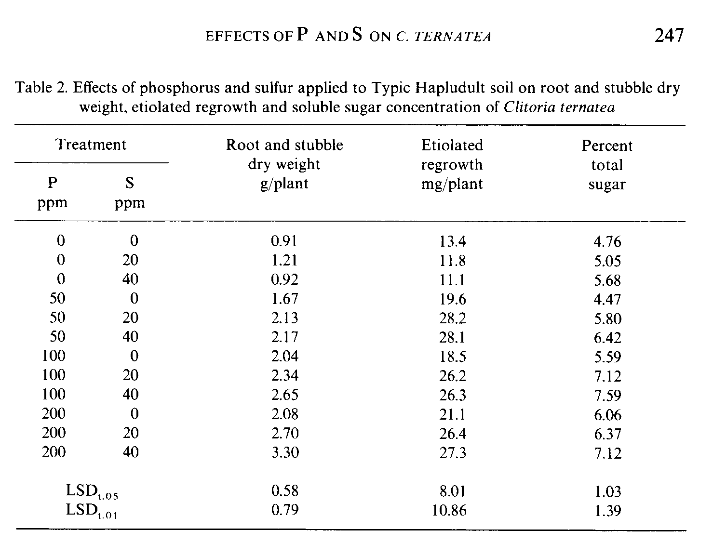
= 0.839). Root and stubble weight may be the most influential single factor determining regeneration of Clitoria ternatea L.
Both P and S increased total sugar concentration (Table 2) but had no significant effect on reducing sugar. Non-reducing sugar behaved in the same manner as total sugar. Reducing sugar is less subject to fluctuation in concentration than total sugar under varying nutritional regimes¹⁷. Sugar concentration was not significantly correlated with dry matter yields for the first or second harvests, but did correlate with dry matter yield in the third harvest (r = 0.736, p < 0.01) and with root + stubble dry weight (r = 0.782, p < 0.01).

DISCUSSION

Phosphorus supply was most critical during the first period of growth. Sulfur at first was probably supplied by seed and soil reserves in amounts adequate for all except the high-yielding P₄ treatment. The sharp drop in dry matter of P₄S₂ treatment in the second and third harvests (Fig. 1) may be attributed to removal of S by vigorous plant growth. However, the decline in yield in the highest S treatment cannot be attributed to depletion of S. Less than 45 mg out of the 120 mg S applied per pot would have been removed by the 3 cuttings, which
248 M. G. ZAROUG AND D. N. MUNNS
totalled about 19 g dry weight (3 plants) and contained about 0.21% S. Likewise, for the same reason, depletion of S cannot explain the diminution in P response with successive cuttings.
The influence of P on yield might have diminished in the second and third harvests because of a lowering of the external P requirement following establishment, as observed for other species^{17,} ¹⁶. The effect was partly due to improvement in yield of plants receiving no applied P. This may have resulted from better root development, which explored a larger volume of soil. Development of mycorrhizae at the lower P levels cannot be overruled⁴.
The main effect of P and S was possibly to improve photosynthesis, by increasing leaf area (M. G. Zaroug, unpublished), by enhancing C0₂ fixation per unit leaf area⁶, and by improving N metabolis^{1,2} . All these effects in turn could also have resulted in higher concentrations of soluble sugars in the storage organs. Rendig and McComb¹⁸ indicated that the chlorotic condition of leaves of S-deficient plants was visual evidence of disturbance of photosynthesis; and suggested that deficiency severe enough to disrupt normal photosynthesis would ultimately reflect in changes in the kinds and amounts of carbohydrates.
Sulfur addition enhanced nodulation. S may have increased nodulation by increasing growth and nitrogen demand^{2,} ^{13.} Nodule size and number were greatest in the treatments that gave the highest yield and sugar concentration. On the other hand, increased nodule mass, if the nodules remained efficient, could have improved nitrogen nutrition of the plants with resulting improvement in the concentration of soluble sugar¹⁴ as well as growth. Work is required to verify possible influence of P and S on the relation between N-fixation and sugars.
Discrepancies between the present observations on nodulation and those of Gates⁹ with Stylosanthes humilis may be due to any of the following reasons: (i) the species difference; (ii) the possibility that his large effect of P may have arisen from delay in nodulation associated with early limitation of plant growth at low P²⁰; (iii) the fact that nodulation in the present experiment was observed only after the third cutting, when the influence of S on plant growth was most clear and the effect of P had diminished.
The lack of response in etiolated regrowth to P supplied above 50 ppm may indicate that the P requirement was small because the plants were not photosynthesizing. Likewise, the lack of difference in etiolated regrowth between the S₂ and S₃ treatments may have been due to similarity of soluble sugar content in contrast with the low sugar of treatment S₁.
The overall effect of P and S was to improve plant growth and nodulation, and to increase concentrations of soluble sugar in storage organs. Part of the increase in soluble sugar may have been channeled to nitrogen fixation with consequent
EFFECTS OF P AND S ON C. TERNATEA 249

accumulation of N reserves, which in perennials can be used to foster early resumption of growth after dormancy¹⁵. Since soluble sugar correlated with dry
matter yield from the third cut but not the earlier cuts, it is likely that carboydrate storage in Clitoria is mainly a function of the immediately preceding growth period.
ACKNOWLEDGEMENTS
This work was partly supported by the U.S. Agency for International Development through the University of Hawaii NifTAL Project.

Received 3 September 1979. Revised December 1979

LITERATURE CITED

1 Anderson, A. J. and Spencer, D. 1949 Molybdenum and sulfur in symbiotic nitrogen fixation. Nature 164, 273-274.
2 Anderson, A. J. and Spencer, D. 1950 Sulfur in nitrogen metabolism of legumes and nonlegumes. Aust. J. Agric. Res. 3, 431-448.
3 Andrew, C. S. and Robins, M. F. 1969 The effect of phosphorus on the growth and chemical composition of some tropical legumes. 1. Growth and critical percentages of phosphorus. Aust. J. Agric. Res. 20, 665-674.
4 Andrew, C. S. and Jones, R. K. 1978 The phosphorus nutrition of tropical forage legumes. In Mineral Nutrition of Legumes in Tropical and Subtropical Soils. Eds. C. S. Andrew and E. J. Kamprath. CSIRO, Melbourne, Australia.
5 Association of Official Analytical Chemists. 1970 Methods of Analysis, 11th Ed.
6 Chen, C. L. H. 1967 Assimilation of ¹⁴CO₂ by Medicago satiua leaves in relation to sulfur nutrition. Ph.D. Thesis. Univ. California, Davis.
7 Fox, R. L., Nishimoto, R. K., Thompson, J. R. and de la Pena, R. S. 1974 Comparative external phosphorus requirements of plants. 10th Int. Congr. Soil Sci. Moscow 4, 232-239.
8 Gates, C. T., Wilson, J. R. and Shaw, N. H. 1966 Growth and chemical composition of Townsville lucerne (Stylosanthes humilis). 2. Chemical composition with special reference to cations, as affected by the principal constituent elements of molybdenized superphosphate. Aust. J. Exp Agric. Anim. Husb. 6, 266-276.
9 Gates, C. T. 1974 Nodule and plant development in Stylosanthes humilis H.B.K.: Symbiotic response to phosphorus and sulfur. Aust. J. Bot. 22, 45-55.
10 Jones, M. B. 1962 Total sulfur and sulfate sulfur content in subterranean clover as related to sulfur responses. Soil Sci. Sec. Am. Proc. 26, 482-484.
11 Jones, M. B. and Quagliato, J. L. 1973 Response of four tropical legumes and alfalfa to varying levels of sulfur. Sulfur Inst. J. 9, 6-9.
12 Macleod, L. B. 1965 Effect of nitrogen and potassium fertilization on the yield regrowth and carbohydrate content of the storage organs of alfalfa and grasses. Agron. J. 57, 345-350. 13 McNaught, K. J. and Christoffels, P. J. E. 1961 Effect of sulfur deficiency on sulfur and nitrogen levels in pastures and lucerne. N.Z. J. Agric. Res. 4, 177-196.
14 Nowakowski, T. Z. and Cunningham, R. K. 1966 Nitrogen fractions and soluble carbohydrates in Italian ryegrass II. J. Sci. Food Agric. 17, 145-150.
250 EFFECTS OF P AND S ON C. TERNATEA
15 Pate, J. S. 1976 Functional biology of dinitrogen fixation by legumes. In A Treatise on Dinitrogen Fixation III. Eds. R. W. F. Hardy and W. S. Silver, John Wiley and Sons, Inc. New York.
16 Plucknett, D. L. and Fox, R. L. 1965 Effect of phosphorus fertilization on yield and composition of pangola grass and Desmodium intortum. Proc. 9th Int. Grassl. Congr. 1525-1529. 17 Rending, V. V. and McComb, E. A. 1959 Effect of nutritional stress on plant composition. I. The interaction of added nitrogen with varying sulfur supply. Soil Sci. Soc. Am. Proc. 23, 377-380.
18 Rendig, V. V. and McComb, E. A. 1961 Effect of nutritional stress on plant composition. II. Changes in sugar and amide nitrogen content of normal and sulfur-deficient alfalfa during growth. Plant and Soil 14, 176-186.
19 Robinson, P. J. and Jones, R. K. 1972 The effect of phosphorus and sulfur fertilization on the growth and distribution of dry matter, nitrogen phosphorus and sulfur in Townsville Stylo (Stylosanthes humilis). Aust. J. Agric. Res. 23, 663-640.
20 Robson, A. D. 1978 Mineral nutrients limiting nitrogen fixation in legumes. In Mineral Nutrition of Legumes in Tropical and Subtropical Soils. Eds. C. S. Andrew and E. J. Kamprath. CSIRO Melbourne, Australia.
21 Shaw, N. H., Gates, C. T. and Wilson, J. R. 1966 Growth and chemical composition of Townsville lucerne (Stylosanthes humilis). 1. Dry matter yield and nitrogen content in response to superphosphate. Aust. J. Expt. Agric. Anim. Husb. 6, 150-156.
22 Spencer, K. 1960 Growth and chemical composition of white clover as affected by sulfur supply. Aust. J. Agric. Res. 11, 500-509.
23 Truong, N. V., Andrew, C. S. and Skerman, P. L. 1967 Responses of Siratro (Phaseolus atropurpureus) and white clover (Trifolium repens) to nutrients on Solodic soils at Beaudesert, Queensland. Aust. J. Expt. Agric. Anim. Hush. 7, 232-236.

